STUDENT LOGBOOK
Student Name: EDWARD YOHANA
Admission Number: BIT/2024/53391
Course: Information Technology
Supervisor: Lecturer Michael Nyoro
Project Title: UNIVERSITY STUDENT PLANNER

WEEK1
Introduction to mobile development
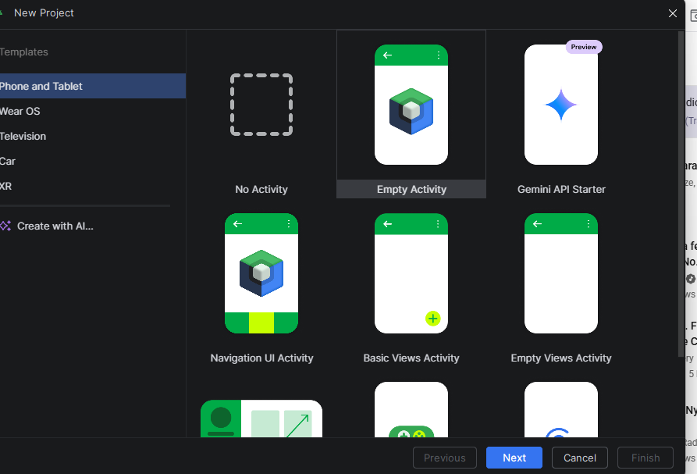
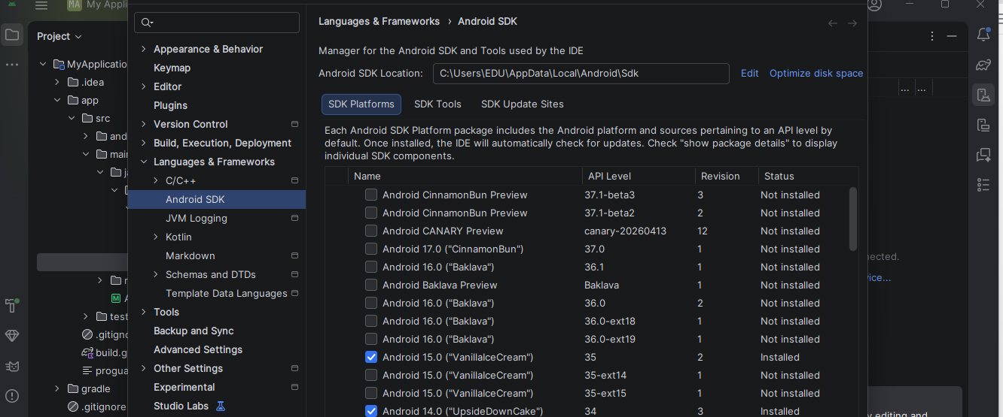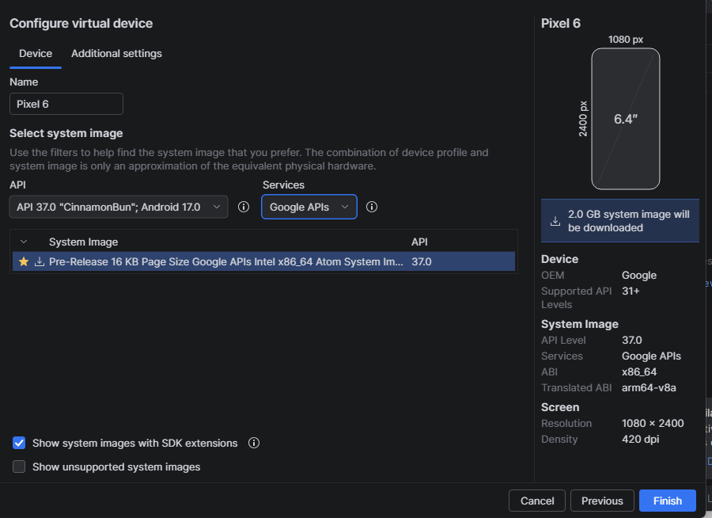
Challenges
.Encountered a problem in enabling the emulator run
.difficulty in understanding kotlin being my first time to interact with it

IDEs for development
Vs code
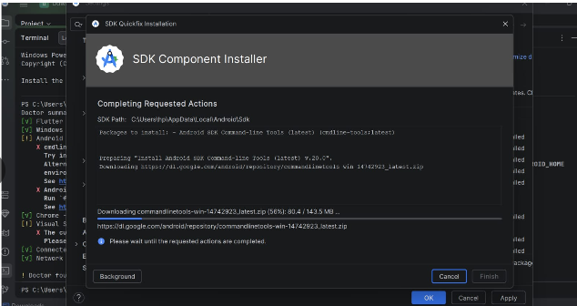
IntelliJ IDEA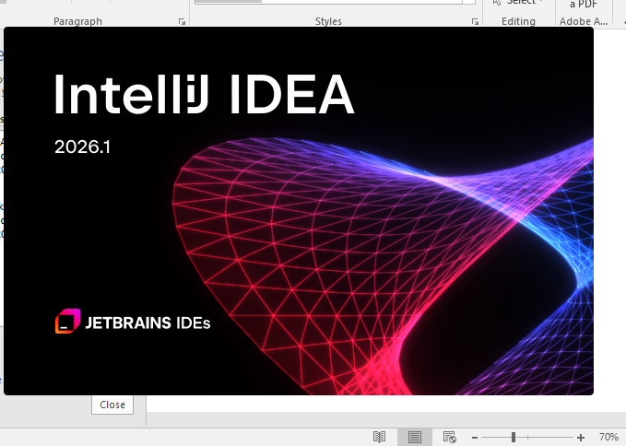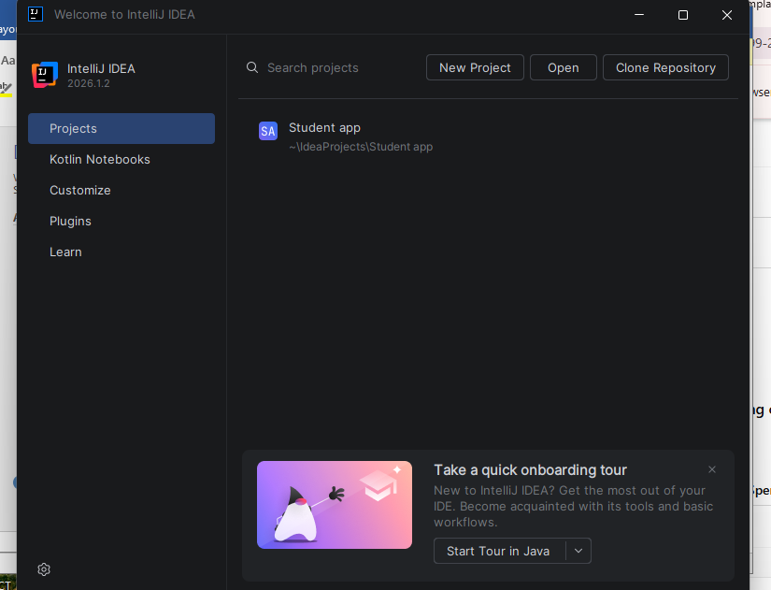

WEEK2
Programming Language
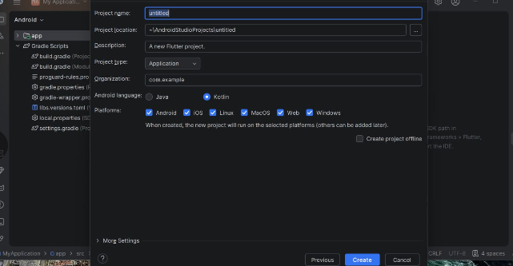
Cross platform practical
Login screen
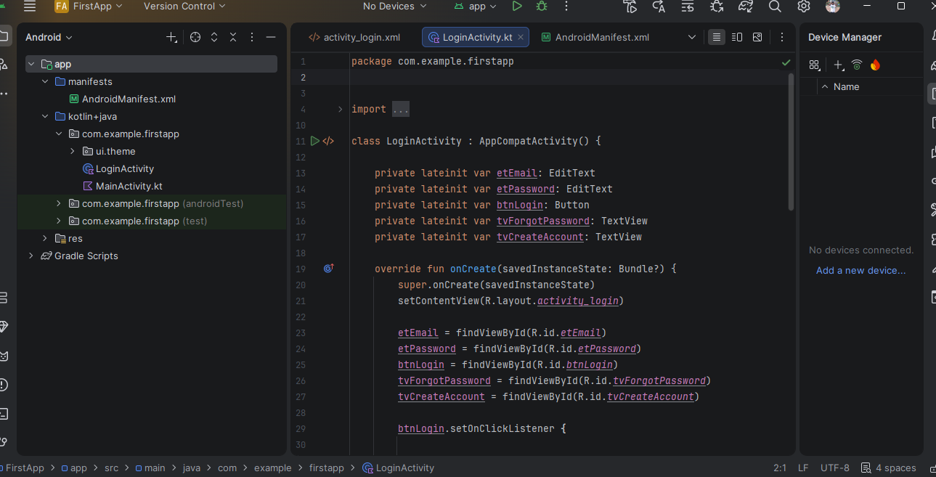
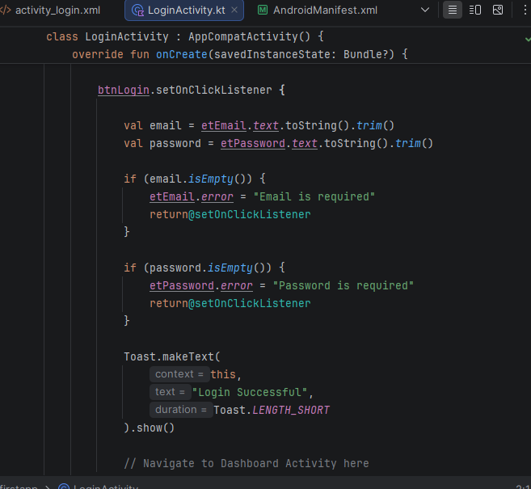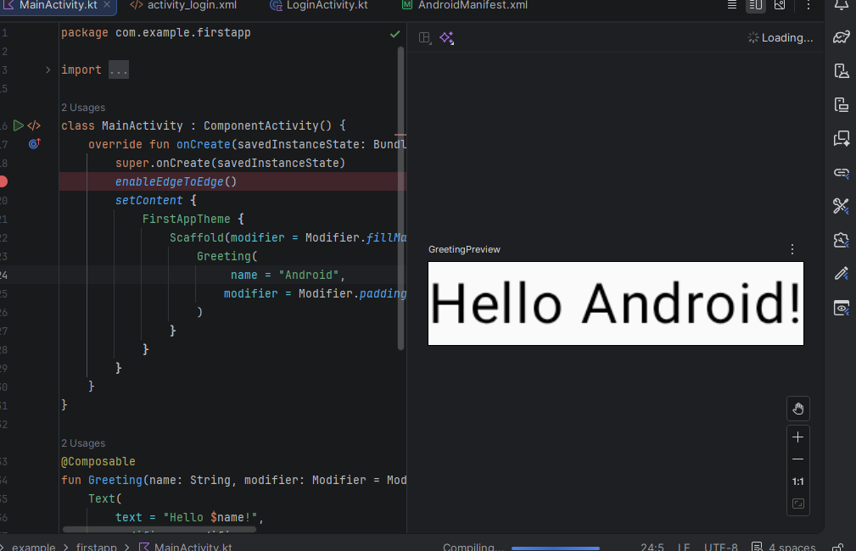

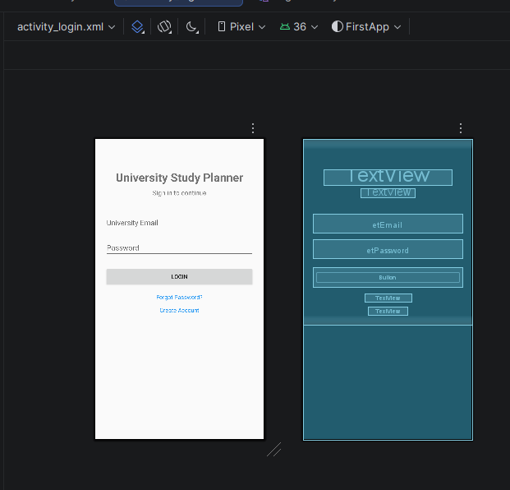

Challenge
.Spent lot of time creating and running the app as it had lot of process

WEEK 3
Wire framing
Figma
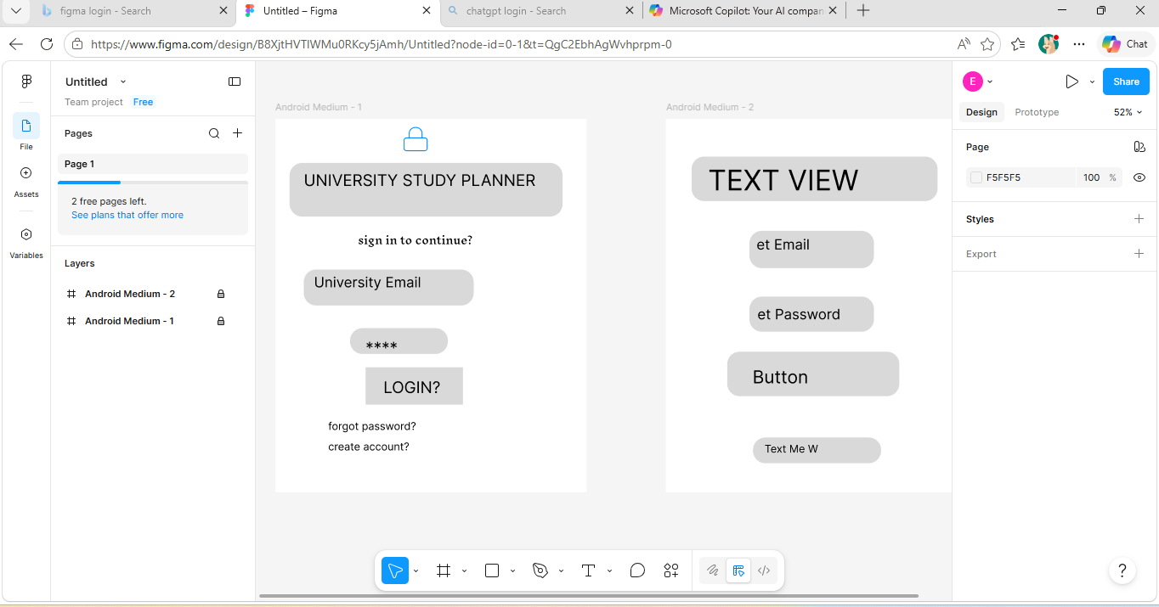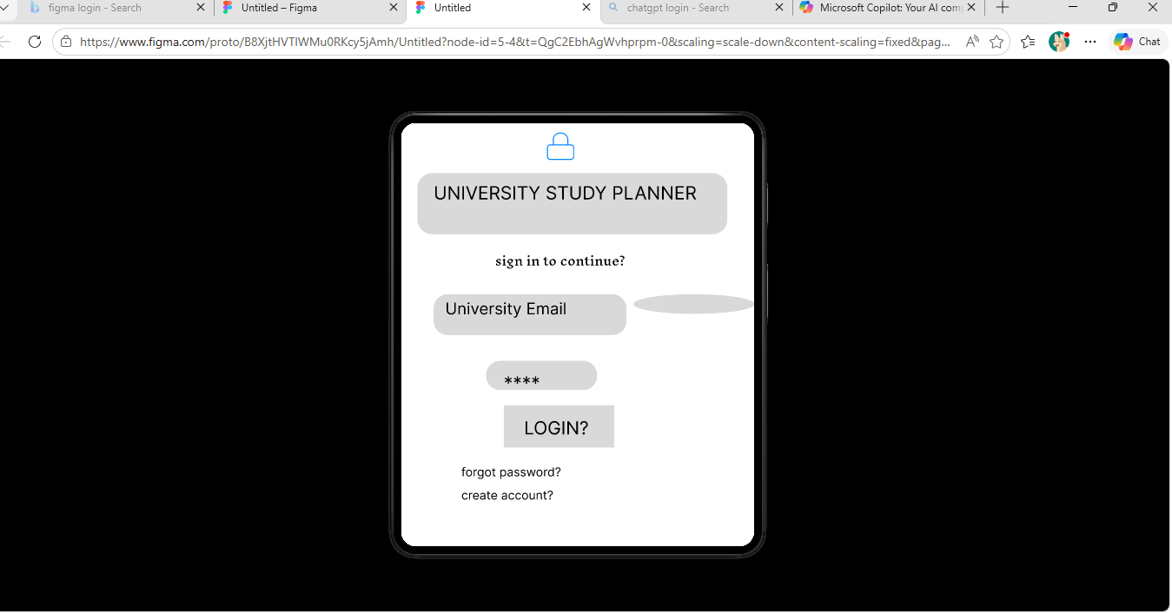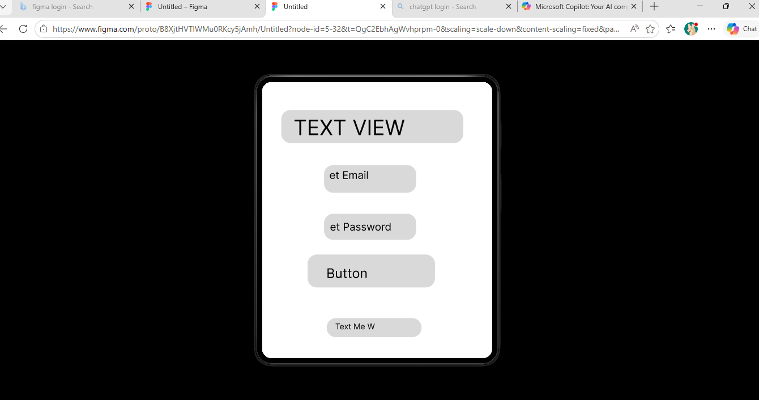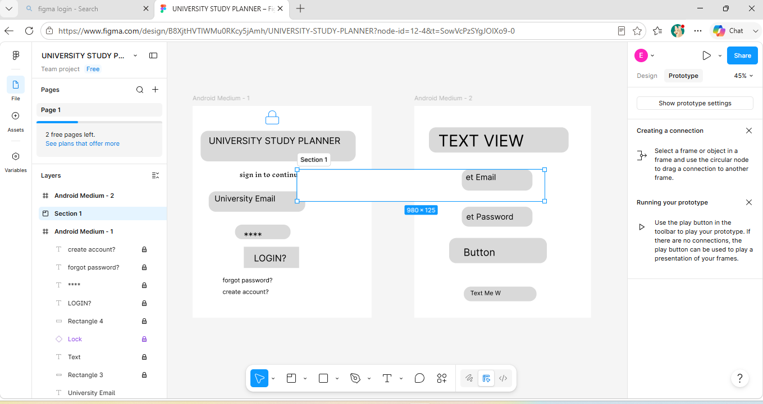

Testing
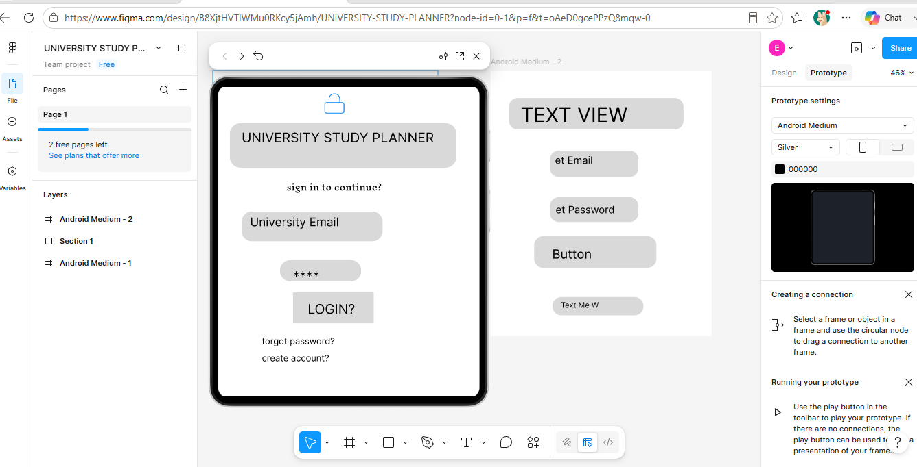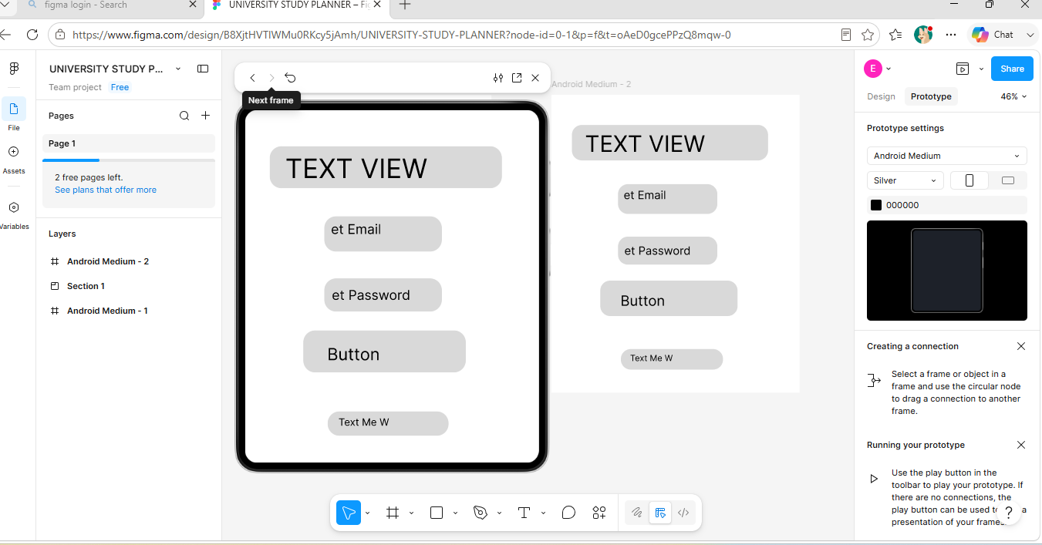

Student signature:
Supervisor signature:

